***Virginia Junior Classical League***

*presents this*

Certificate of Excellence

*to*

Michaela Broyer

*of*

Grace Preparatory School

*for*

*2nd Place in Children's Book*

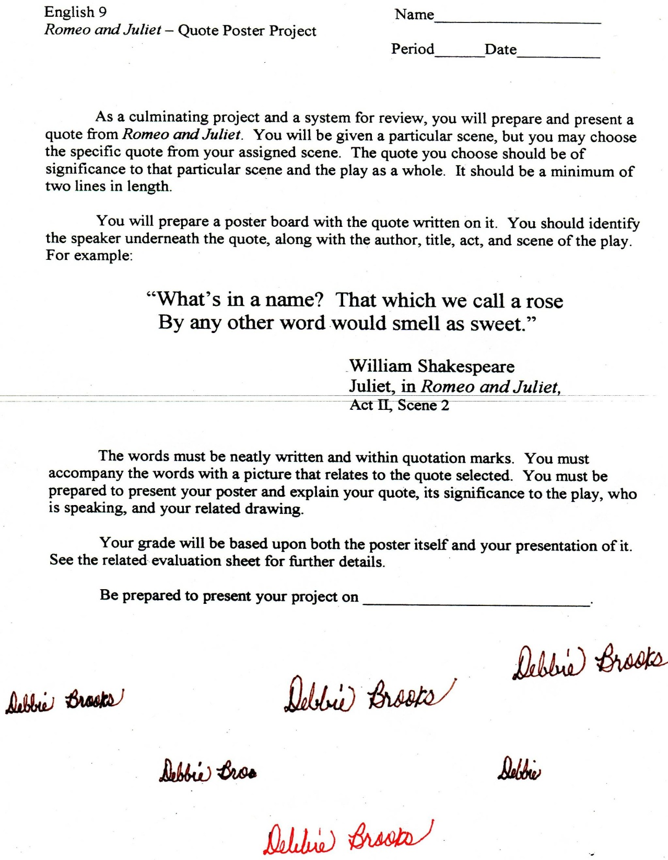

Microsoft Office Signature Line...

*a.d. viii Kal. Dec. MMDCCLXVII A.U.C. 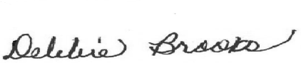*

***Virginia Junior Classical League***

*presents this*

Certificate of Excellence

*to*

Ash West

*of*

Grace Preparatory School

*for*

*2nd Place in Children's Book*

**

Microsoft Office Signature Line...

*a.d. viii Kal. Dec. MMDCCLXVII A.U.C. *

***Virginia Junior Classical League***

*presents this*

Certificate of Excellence

*to*

Maddie Davis

*of*

Grace Preparatory School

*for*

*4th Place in Life*

**

Microsoft Office Signature Line...

*a.d. viii Kal. Dec. MMDCCLXVII A.U.C. *

***Virginia Junior Classical League***

*presents this*

Certificate of Excellence

*to*

Michaela Broyer

*of*

Grace Preparatory School

*for*

*4th Place in Pentathlon*

**

Microsoft Office Signature Line...

*a.d. viii Kal. Dec. MMDCCLXVII A.U.C. *

***Virginia Junior Classical League***

*presents this*

Certificate of Excellence

*to*

Stephen Watkins

*of*

Grace Preparatory School

*for*

*5th Place in Sculpture*

**

Microsoft Office Signature Line...

*a.d. viii Kal. Dec. MMDCCLXVII A.U.C. *

***Virginia Junior Classical League***

*presents this*

Certificate of Excellence

*to*

Maddie Davis

*of*

Grace Preparatory School

*for*

*7th Place in Mottoes, Quotes, and Abbreviations*

**

Microsoft Office Signature Line...

*a.d. viii Kal. Dec. MMDCCLXVII A.U.C. *

***Virginia Junior Classical League***

*presents this*

Certificate of Excellence

*to*

Ash West

*of*

Grace Preparatory School

*for*

*7th Place in Sight Latin*

**

Microsoft Office Signature Line...

*a.d. viii Kal. Dec. MMDCCLXVII A.U.C. *

***Virginia Junior Classical League***

*presents this*

Certificate of Excellence

*to*

Glen Buchanan

*of*

Grace Preparatory School

*for*

*9th Place in Charts*

**

Microsoft Office Signature Line...

*a.d. viii Kal. Dec. MMDCCLXVII A.U.C. *

***Virginia Junior Classical League***

*presents this*

Certificate of Excellence

*to*

Stephen Watkins

*of*

Grace Preparatory School

*for*

*10th Place in Geography*

**

Microsoft Office Signature Line...

*a.d. viii Kal. Dec. MMDCCLXVII A.U.C. *